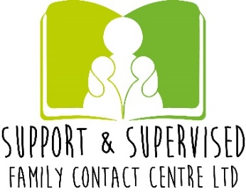

Costs & Services

Please note all fees at present are VAT Free

Updated February 2021
Referral Fee  £50.00 | Referral Fee  Non-refundable- is to be paid prior to any contacts commencing.
£25 per session | Tech Contact- 23.03.2020  Tech Contact in the form of Zoom for all our Service users. Zoom contacts are still supervised and are a 3 way booked meeting between staff, child/ren and who the contact is intended for.  The supervisor can end the session at any time if the contact either becomes distressing for the child or any inappropriate behavior or comments are observed within the session.
With a Contact session Report  £60.00 per hour  Without Report  £50.00 per hour | Supervised Contact  - The Supervisor will remain with the children and parent /family member that the contact session is intended for. A Contact report will be completed on the interactions and observations throughout the duration. There are variations to supervision levels that we offer from Low – High which can be confirmed in the Referral and again in the Agreement form.  - For a Supervised Contact with No contact Session report there will still be an attendance record and hand written basic notes which will be kept on the families file.
Supported Contact £35.00 per hour | Supported Contact  The family will be allocated a room that they can access for the specified hours required. Staff will be in the building however not in the contact room continuously.
With Report  £60.00 per hour  Without Report  £50.00 per hour | Community Contact  This takes place in the local community and is arranged in advance to ensure that it meets the needs of the children and their families. An example of Community contact would be a trip to the local park.
Single payment  £20.00  Per Handover | Handover Contacts  We can facilitate the picking up and dropping off of children to and from the center.
Room Only  £25.00 per hour | Room only Contact Sessions  You will have full use of the contact room for the duration of the contact session.
Meeting Room  Without Refreshments  £15.00 per hour  With Refreshments  £20.00 per hour | Meeting Room only:  NOT AVAILABLE AT PRESENT DUE TO COVID RESTRICTIONS  Within Welland Workspace, Business & Training Centre there is an additional room available for an hourly fee for meetings conferences or training etc. If you wish to use this service this can be booked through S&S Family Contact Centre Ltd. Please note as much notice as is possible is needed as other business within the building also have accesses to book this room.

Support & Supervised Family Contact Centre Ltd: 11468241
Phone: 07968448732 – 01406 371041
Email: ssfamily.cc@gmail.com
Website: ssfamilycc.com
NACCC Accredited-1665/2
Welland Workspace, Business & Training Centre
Office number 15 & 16
10 Pinchbeck Road, Spalding, Lincolnshire, PE11 1QD
