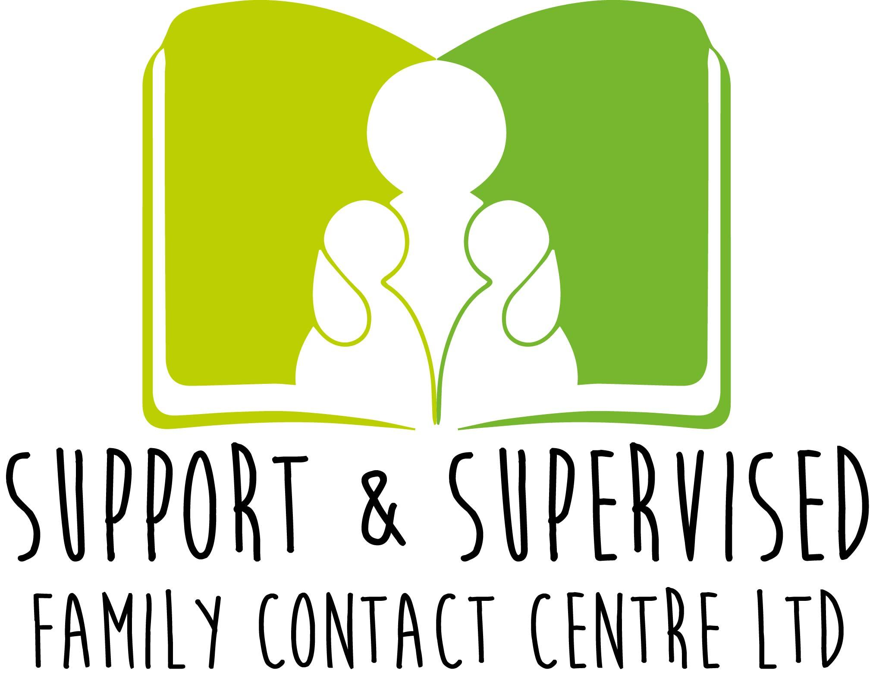  CONTACT AGREEMENT  &  Risk Assessment | DATE:  NACCC Accredited  No: 1665/2  National Association of Children’s Contact Centres  Family Name:  Type of Agreement: Supervised Contact  CLIENT ID: NO  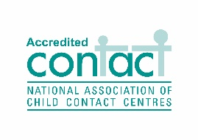
AGREEMENT BETWEEN CENTRE & SERVICE USER’S

1 | Names of children  & relationship to each other | CHILDREN | RELATIONSHIP
2 | Name of parent/s family members  (Anyone not named may not attend without agreement) | PARENT/S | RELATIONSHIP
3 | Venue  Name & Address (if not S&S Supervised Family contact centre’s venue) | NAME  Support & Supervised Family Contact Centre | ADDRESS  Welland Workspace, Business &Training Centre Office number 15  10 Pinchbeck Road, Spalding, Lincolnshire, PE11 1QD
5 | Times and days  of Contact sessions | TIMES | DAYS
6 | Type of Contact  High-Supervisor is in constant site and sound  Medium- Supervisor may leave the room briefly.  Low- Supervisor can leave the room on occasion. | SUPERVISED  HIGH: □  MEDIUM: □  LOW: □ | SUPPORTED  Further info please state below  Supervised Contact Only  Is a Supervised Contact Report to be completed? (please tick) □

7 | SUPERVISED | SUPPORTED | HANDOVER | ROOM HIRE ONLY | OTHER  Please specify
 | □ | □ | □ | □ | □

8 | Is the contact contributing to any assessment or support work of the adults with the children (Supervised Contact only)?

 | DESCRIPTION | □ Yes/No/NA | COMMENTS
1 | Can Photos be taken within the session by parent/family member?  There is a no video or audio recording policy. | □ Yes  □ No  □ N/A | Briefly (explain why)
2 | Is the Contact Supervisor able to take photos for the families/Social workers? | □ Yes  □ No  □ N/A | Briefly (explain why)
3 | Can Parent/Family member bring in food, snacks, toys, clothes etc.? | □ Yes  □ No  □ N/A | Reason: (if not why not)
4 | Supervisor must accompany family members to toilet when the child/ren go? | □ Yes  □ No  □ N/A | Briefly (explain why)

5 | Is a communication book needed between Carer (of the child/ren) & Service user? | □ Yes  □ No  □ N/A | Is assistance needed
6 | For the duration of the Contact session does contact have to remain on site? | □ Yes  □ No  □ N/A | Please specify:  □ With Supervisor  □ Without Supervisor
7 | Mobiles to be switch off at all times? | □ Yes  □ No  □ N/A | Reason:
8 | Do Parents/Family Members need to be on site by a certain time prior to contact commencing? | □ Yes  □ No  □ N/A | Reason:
9 | Is there a non-molestation order in place which prevents parents coming into contact with one another? | □ Yes  □ No  □ N/A | Brief Reason:
10 | Parents/Family Members to say their goodbyes?  ARRIVAL-  ENDING - |  | □ In the centre  □ At the car  □ In the room  □ Other
11 | Any other relevant Information  -Please also adhere to all Policies, Procedures and Guidance which S&S Family Centre will provide you with regarding Government and the Public Health Authority in connection with Covid19.  -The agreement is subject to change. This is a brief guidance as we continue to review the contacts | -Facemasks to be worn in communal areas.  -Keep a 2 metre distance. Face mask may be removed once in the contact room.  -Please continue to keep 2 meters between you and the supervisor ( Children are Exempt) | -Hand sanitisers & masks are available in all contact rooms and the reception area when you sign in.  -Rooms are disinfected between family’s sessions.  -For larger families Contact may take place in the conference room.

The role of the Supervisor (Supervised & Supported Contact)

- Supervised Contact The service specialises in particular in Supervised Contact sessions where the supervisors will remain in the room for the whole duration of session, dependant on the level of Supervision as stated above.

- Supported Contact. The Contact Supervisor will be present to do the greeting and ending of each contact session. They will not remain in the room with the named Parent/Family member who the contact is intended for but will be present in the building and will check on the contact periodically.

- Whilst it is the parent/ family member’s responsibility to look after their child/ren in a contact session. A member of staff at times may have to Intervene, particularly in the bellow instances.
- If a child appears physically unsafe in any way or handling could be improved.
- If there was a hygiene issue around washing hands, equipment, disposing of nappies etc.
- If the parent/family members were becoming agitated and the child’s distress is increasing.
- If the parents/family members are becoming agitated with each other
- If inappropriate language, conversation is used to, or around the child/ren. This could include any discussion around court proceedings, derogatory comments about the person/s who is the main carer for the child/ren.
- If the child/rens behaviour is deteriorating due to lack of attention or structure from parents.
- Supervisors are present to ensure that contact is carried out in the best interests of the Child, to ensure that they are cared for in a safe and secure environment.
- They are also there to support the adults in their parenting and ensure a positive contact for all.
- Supervisors will take notes during sessions, if a contact report has been requested by i.e. the courts, Cafcass or a Social worker for instance then a full report of the session will be completed by the supervisor to share with them.
- You have the right to see and access your reports which will contain an account of the observations and interactions that take place from when the family members attend the centre until they all leave.
- To access your Contact reports please request them through your legal team, social worker whichever is applicable. For Private contacts, reports can be requested by the person/s attending the contact session only.
- All Contact reports and documents are confidential and only shared with the relevant parties and agencies.
- Files will only be kept for the duration of time that the service is needed.
- Contacts will be regularly reviewed and any changes that may need to be made will be discussed and the contact agreement amended where applicable.

Centre Policy: Contacts may be cancelled and/or suspended: -

- If any adult present is physically or verbally abusive to anyone in the building; this includes your own children
- If any adult attends contact under the influence of alcohol, or any substance that may affect their behaviour during the session.
- Please see separate Terms & Conditions for further Centre policies

OFFICE USE
□ Copy Of Signed Contact Agreement

□ Ground Rules for Visiting Persons Supported Contact sessions
□ Terms & Conditions
□ Ground Rules for Person/s bringing Child/ren to the Contact Centre
□ Privacy Policy
□ Confidentiality Policy
□ Feedback Form

Signatures:
By signing, you agree to abide by the Contact Centres
Terms & Conditions - Procedures & Policies

Date of meeting: ………………………………………………………………………….

Parent/Family member: ……………………………………………………………….

Contact Referrer: …………………………………………………………………………

Contact Centre Manager: …………………………………………………………….

Supervisor (if applicable) ……………………………………………………................

Support & Supervised Family Contact Centre Ltd: 11468241
Phone: 07968448732 – 01406 371041
Email: ssfamily.cc@gmail.com
Website: ssfamilycc.com
NACCC Accredited-1665/2
Welland Workspace, Business & Training Centre
Office number 15 & 16
10 Pinchbeck Road, Spalding, Lincolnshire, PE11 1QD
